Process Report SEP3

Students  
Oskars Arajs: 266534  
Taha Mohamed Alzein: 269055  
Fadi Dasus: 266265  
Muhammad Nadeem: 266704  
Balkis Ibrahim: 260092  
  
  
  
  
Supervisors  
Christian Flinker Sandbeck  
Ole Ildsgaard Hougaard

ICT ENGINEERING   
THIRD SEMESTER 2018

Table of Contents

1. Introduction 3

2. Group Description 3

3. Project Initiation 5

4. Project Execution 6

4.1 Version Control: 7

4.2 SCRUM 7

4.3 Sprint backlog: 9

5. Personal Reflections 14

6. Supervision 17

7. Conclusions 17

# Introduction

The current document is meant to inform both the team and the reader about how the planned activities worked out and how the collaboration and workflow went in our group. For this project, there was no mandatory given topic, but instead, we had the possibility of choosing the methodology we want to use. The chosen working methodology for this project was SCRUM since it was the ideal way of managing the team in an agile way. The group’s activities for this assignment were organized in sprints. There was a total of 16 sprints for the given project and each of them was held weekly one for each sprint. Our group scheduled the weekly sprints to take part every Thursday at 8:20 AM. The meetings were scheduled to last around 8 hours per meeting. Each sprint had its own sets of requirements all having a grade of importance and a workload estimate. Some tasks took more time to complete than originally estimated and at some point, we fell behind of schedule because of this. A time schedule in form of a Gantt chart was made for this project and this helped in keeping track of the given tasks and helped in organizing our group work. At a certain point in the project, we stumbled with certain tasks and had difficulties in advancing further. As a result, we seemed help from our supervisors during the scheduled meetings, which were held each week on Thursday. The meetings went well and the problems that we encountered were solved, allowing us to advance further with our project. The workflow went smoothly in most cases since we had a well-organized team prior to starting the work. Each member did his tasks and did not hesitate to ask for help when problems started appearing.

# Group Description

Our group is made of 5 people. Them being Oskars Arajs, Taha Alzein, Fadi Dasus, Balkis Ibrahim and Muhammad Nadeem.

Oskars comes from Latvia and he has studied electrical engineering in Latvia. He has worked in the field for a while each summer while studying and realized that that carrier isn’t for him, so he came to Denmark to pursue a new challenge in ICT. During his spark-filled early days as an electrician he got to work on construction sites and for private customers and he learned the value of hard work and determination. He has experience working on different projects, but he did so alone. Because in Latvia there is a different teaching method where most of the projects are done individually. So, he was a good worker but had to learn to rely on others.

Taha comes from Syria. He is like the leader of our group because he has a lot of experience working with people and different projects. He studied software development and so he is our go-to guy when we have questions, or we need to settle an argument. He has been underlying to the big bosses and he has been the leader of his own projects. He likes to try new things and be a part of every part of the project. As his Belbin role is a specialist he truly gets irritated when his time is being filled with nonsense or otherwise being wasted.

Muhammad comes from Pakistan. At first, he seems shy and doesn’t want to bother the rest of the team if he doesn’t know something. But it turns out that he is a smart and talented guy that knows a lot programming, even though last semester was his first-time coding and developing. His Belbin roles described him accurately, but he didn’t let that stop him from getting really in tune with java and easy run with databases. His technical skills and theoretical knowledge comes in handy when the project period starts, and the deadlines are approaching.

Fadi also comes from Syria. He studied as a dental technician and worked in that field for two years. He comes on as a funny and sincere guy but if you start messing up the projects he is a part of he will get frustrated and give arguments on why you should not have done that. Thanks to his previous education and practical training, he knows the importance of being precise and planning what needs to be done. He is very meticulous keeps an eye on the deadlines so that we don’t miss anything while being distracted by the project or other assignments.

Balkis is 21 years old, and she is also from Syria. She came to Denmark two years ago. She has never imaged before that one day she would be here in Denmark but the war in Syria forced her. she does not have any bachelor degree in other programme. Apparently, because she is the youngest. She is always optimistic and tries to motivate all other members. she likes to laugh all the time. She does look a serious person but in fact, she is so funny and friendly.

# Project Initiation

In this chapter, we will discuss how the topic for this project was received by our group. The main requirement for the topic was to implement a 3-tier architecture for our system. Our group decided to create a “Movie World System”. The purpose behind the idea is to give developing countries an opportunity to use an online transaction for purchasing movie tickets and give the people availability to stream movies from the comfort of their home. The formation of the semester project groups was left for the students to decide. Since most of us worked together previously we decided to do things in a similar way this semester with the additional new member.

As mentioned in the introduction SCRUM was used to organize and plan the meeting. We decided on using this agile method because we have experience with it and we feel comfortable using it. The time needed for the development of this project was separated in sprints. We held our meeting every Thursday because that was is the project day that the university has allocated for us. For this to work well we considered each sprint as a milestone. Meaning, to start the next sprint, the previous one needs to be finished. However, this semester turned out to be more difficult then we imagined. In return, it made it difficult to follow through with the sprints and reaching our milestones. But we pushed through and reached our goal. To help us reach our goal we also used project planning tools. These included an activity monitor called “Gantt chart”. We kept a progress log book. Based on it, we were able to document how each sprint went and what has been accomplished during that meeting. Estimated hours have been given for each task of the respected sprint and at the end, actual hours could be subtracted for each task.

Another tool used for this assignment was in the form of a risk assessment table which served as a reminder of what risks this project would pose and what would happen if some rules would be broken. Of course, we took into consideration that some of our group members live further away than others. That’s why we stayed in touch via social media and tools like Slack to make arranging meeting easier.

For this project we wanted to create an application that would serve as a platform in which to watch movies or buy tickets online for movies. Knowing this we determined that there are 2 tasks that need to be taken into consideration in order for this project to be satisfactory. The first one would be that the Client should be able to book a ticket via this system, and the second task is that the Client should be able to stream movies if he has a valid subscription.  
Knowing these tasks we are able to create the methodologies that we shall use for this project, and create delimitations that we might apply.

When creating the delimitations part of the project we chose the aspects that, in our opinion were most important for this project and we discarded those that weren’t.  
The Risk assessment was made in order to analyze all the possible risks regarding this project. In order for us to be able to deliver a good project we needed to understand what kind of risks are we dealing with.

# Project Execution

In this chapter we will discuss how the execution for this project went in our group and what methods were used to meet the deadline.

For this project we used Scrum as we did last semester. It was perfect for us since we have experience using it and it hasn’t failed us. Since we defined all of the task relevant to this project we were able to divide them into sprints with each sprint being one week long.   
While using the Unified process methodology we followed the 4 steps, inception, elaboration, construction and testing. While we separated the work between us everyone was still knowing what the other people were doing in order to understand the code as best as possible.

In the inception face, we discussed and developed user stories that were made for this project, managed all of the requirements and scenarios.

In the elaboration face we spent time creating all of our relevant diagrams such as Activity, class, sequence and use case diagrams. All of this helped us visualize the concept and gives us a better understanding of how the system should respond and act.  
In the construction face, we started coding our system on the base we created in the elaboration face. Taking into account all of the previously made diagrams for understanding the needed methods.

In the testing face, we tested our application in such detail as we deemed necessary. Just to see if everything works as intended and if any exceptions happened correct them.  
There where, at points, moments where we hit a wall and didn’t know how to fix a problem and had to seek help from the supervisors. Other times we just debated the topic and discussed it between our own.

As for assistance materials, we used mostly online materials, tutorials and instructive videos all of which helped us reach the desired end-point of our project. Since this semester we had to work with different things, like web APIs and security functions in general, we had to look for information and seek assistance from our supervisors.

In Addition we created a burndown chart in Figure 1. to show us our progress during the weeks worked on the project.

## 4.1 Version Control:

GitHub has been used for version control. As we are a group of 5 members so all 5 are the contributors for push and pull requests. For more information repository is provided

<https://github.com/zeintaha/ICT-SEP3>

## 4.2 SCRUM

During the development of the system an agile framework has been used which is SCRUM.

Roles were assigned to our group members so that each one of us will know what his task during the Scrum is and how he should prepare for the next meeting.

Our roles were:

**Product owner**:

The whole group members were presents the product owner of our system. The purpose was to create a vision of what he wishes to build and convey that vision to the scrum team.

**Scrum master**: Taha Alzien

Taha was the Scrum master in our group. His purpose was to maintain a good and calm environment. Also he was the one who planned out the Scrum meetings. During the meetings he was the one to set up who is responsible for certain tasks. There were some obstacles that our team encountered but not for a long time because Taha was trying hard to find a solution for the problem.

**Development team**: Balkis Ibrahim, Fadi, Oskars and Nadeem

They work on creating and improving the system. The main goal of the development team was to implement the tasks which can be found in the sprints also to deliver the requested and committed product increments. During this project, our development team worked hard in order to achieve the set-up goals.

|  |  |  |
| --- | --- | --- |
| **Sprint ID** | **User Story** | **Priority** |
| 8 | As a Guest I want to be able to book a ticket for a certain movie, so that I can reserve a place for that movie. | High |
| 9 | As a guest I want to be able to book a ticket for a certain movie, so that I can reserve a place for that movie. | High |
| 10 | As an Admin I want to be able to add movie to the system, so that the Customer can see it | High |
| 11 | As an Admin I want to be able to add movie to the system, so that the Customer can see it. | High |
| 12 | As an Admin I want to be able to add movie to the system, so that the Customer can see it. | High |
| 13 | As an Admin I want to be able to remove movie from the system, so that I can delete a movie. | High |
| 14 | As a guest I want to be able to select a movie, so that I can see the movie details | High |
| 15 | As a Customer I want to be able to stream movie, so that I can watch movie at home. | High |
| 16 | As a guest I want to be able to pay using electronic payment method for my reservation or subscription. So that I can have these services. | medium |
| 16 | As an Admin I want to be to read messages, so that I can guest input. | Low |
| 16 | As a guest I want to be able to send messages, so that the Admin can read it. | Low |

## 4.3 Sprint backlog:

First two sprints:

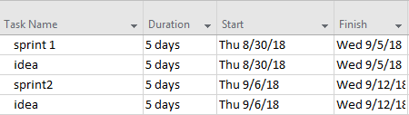

We spent the first two sprints on generating ideas for the project.

Third sprint:

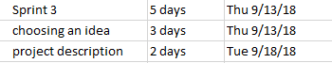

We decided after deep researching on what idea we will implement, and we also worked on the project description.

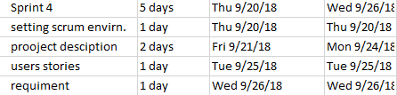

In the fourth sprint work has been put on setting scrum environment, project description, Analyzing the problem we have by setting up the requirements and wrote some user stories

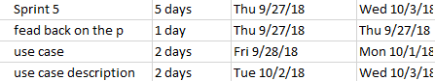

We got the feedback for project from our supervisor on the fifth sprint and we started out to design our project.

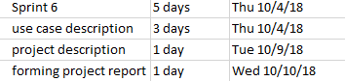

We continued designing, it took long time to design the use case and writing the description for it

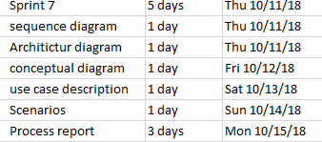

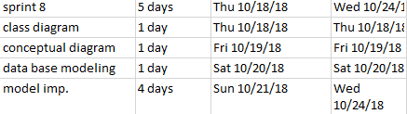

On sprint 8 we started implementation with the model in java.

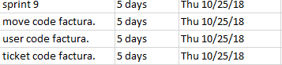

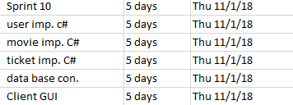

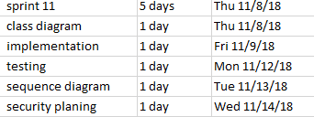

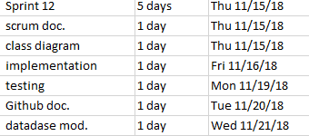

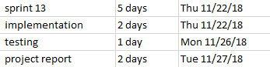

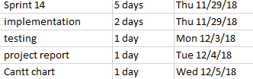

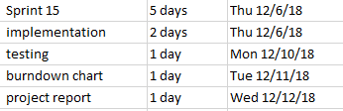

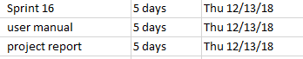

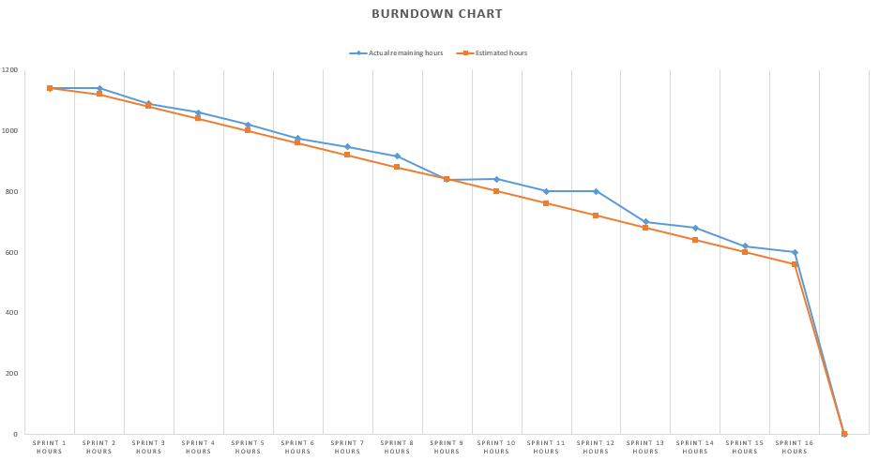

Orange line represents the estimated hours.

Blue line represents the Actual remining hours.

From the diagram above we can obviously see that our sprints were not equaled in hours but due to the project plan we were given we had to work 8 hours per week during the first three months, and at the lasts sprints we worked 56 hours, this clarifies the irregular drop for the tasks. The diagram also shows we were late at some point but in the end, we managed to do all the work we planned to without any delimitations.

GanttChart: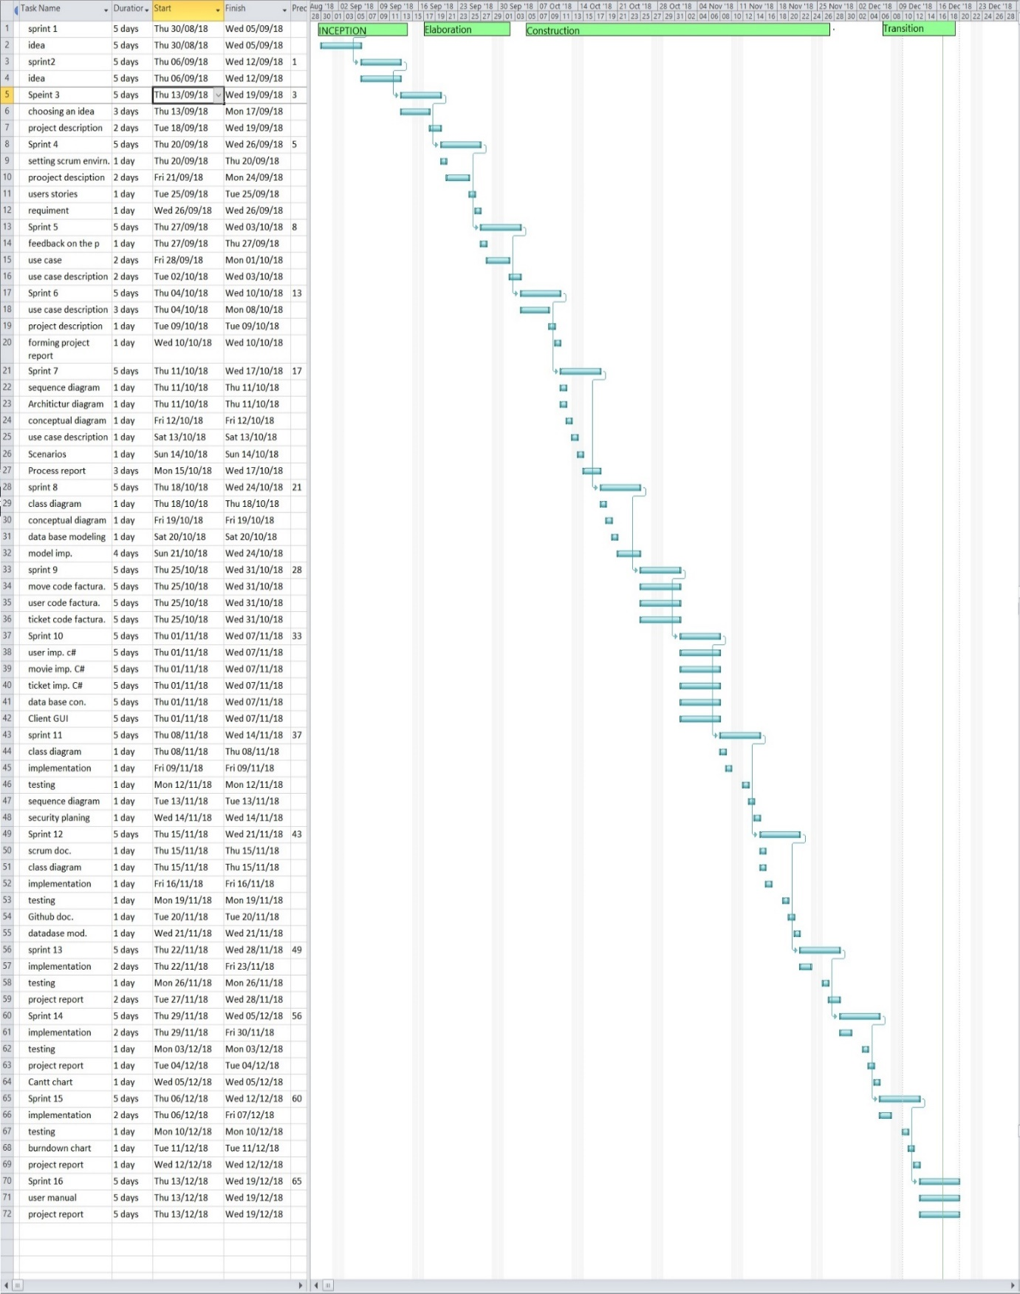

# Personal Reflections

Oskars  
My biggest surprise during this project was the fact that we couldn’t decide on the idea at first, so that gave us a challenge to come up with an idea that would actually benefit someone. But the idea we came up with was delightful. A movie viewing platform for countries that have been denied the services of platforms like Netflix or Popcorn time. It was interesting to work with the team since we have become good friends and enjoy one and another’s company. We had a good time making the project. This semester was really difficult since we had to learn a lot of new things like the 3tier-architecture, web services and etc. So making this idea work was really difficult.

In my opinion, the best way of how to choose an idea is to make a list of requirements needed for the project and make a list of available topics that the supervisors agree on and discuss in detail that list. This way we already have a list of probably topics and we won’t have to go back and forth to one and the same idea. Or have trouble coming up with ideas.   
This semester we started off with 3 similar ideas. But since we had difficulties agreeing on a topic with the supervisors, we were trying to make the similar ideas into one possible project.   
Another thing I think we could have improved on was the amount of time we are meeting. I believe that if we would meet twice a week and work two thirds of the time in each meeting we would have allocated more time for us to finish the project with time to spare.   
Because up till now we were meeting once per week, and most of the time it was working well, but when we were falling short of time we would have really benefited of meeting twice per week from the start.

Balkis  
It is interesting working in a group where you are the only girl. But these guys are really friendly and helpful. If anyone has difficulty understanding the task at hand, they explain everything as best as they can. And I feel that I also give a contribution to the team effort. It was easy to get overwhelmed at some points, because the dead-line was approaching quickly.   
But following our sprints helped us keep track and gave us head-up for the upcoming tasks. We would sometimes sit afterhours to discuss the next meetings, so we would have extra time on our hands. One time to help us work, we made pizzas in the morning. That was a nice treat for all of us to forget about the pressure of university life and the upcoming project deadline.   
I was a little concern about the meeting times and if all of the group members would be able to come to our meeting and spend time productively. Since it was my first time working with these people I wasn’t quite sure about their work ethic or their sense of responsibility. But turns out my concerns were unneeded since our group members only missed a meeting or two due to illness.

I enjoyed the time we spent doing this project, but the most interesting part for me was understanding the three tiers architecture system and how it differs from a distributed system. Since the main goal of this semester was to understand the different tiers, I took it on myself to study in my free time for better understanding.

Taha:  
Since I worked with most of my group members before I know how much they have learned during these months. All of us gained a lot of knowledge that was needed to build this application. I enjoyed the fact that we were discussing a lot of things during the creation of this program. Fadi especially rose to the occasion. He challenged me on a lot of things and he gave a lot of valuable points to consider. But for the most time we had fun working on this project since all of us spent time together in school.

The security part of the project was really interesting since it gave us a chance to actually think of how the application my react to unwanted inputs or unauthorized user access. Thinking in this way helped me realize the minimal things a software engineer has to do to make his system a little safer in terms of sql injections.

There were moments when I had some trouble regarding the programming language C in order to complete our requirements for the semester project. But we made a study meeting unrelated to our semester project and we just studied C for our better understanding. It was really beneficial to learn an additional programing language. Since I have been working in the field of IT before, the benefits of another programing language is really good for a software developer.   
The most challenging part in my opinion was working with a cloud database and creating a payment system for our project. Our supervisors were upfront with the issues we might face, but they still gave us their full attention and helped us reach our desired goal, which was, creating a good desktop application that would provide user with the opportunity to buy tickets for upcoming movies, or , to pay a subscribing fee and watch them from the comfort of their own home.

Nadeem:  
In my opinion we could have gone with a different color for the theme of our application. But regardless of the color the design of the application is my favorite part of our r system. It looks really modern and easily understandable. I strongly believe that the first glance of an applications design will determine if it will be good for the consumer. And our application does just that. It catches you with the layout and nicely design functionality.  
Our meetings went as expected. Each meeting we discussed our progress and things we need to do for the upcoming meetings. I would have liked it more if we could have made our meetings after class since I have a long way to drive to get to VIA. But at the end of the day I am willing to commit to the team effort.

I don’t really enjoy spending a lot of time looking for information. I prefer to be coding. It takes a lot of time but at least something is happening. Of course, it doesn’t mean that if I have to research something I won’t do it. It’s just that I don’t enjoy it that much.   
But coding took a lot out of us regarding energy to code. A lot of things to consider and even more things to implement so that everything works smoothly. There are always more things to improve on even with this project but as it stands now I am very happy with our accomplishment.   
  
Fadi:  
I have worked with most of the people in my group before, so I was fully aware of their strengths and weaknesses. While the project we did took a considerable amount of time and effort, we managed to pull it off and finish the product successfully. The project group did an amazing job on project and I am really happy for the effort the team put in. They made the long hours go faster and when the time came everyone went the extra mile to get a fully working system.

I was really interested in working with multiple programing languages at once since it was one of the requirements for the project to make it two languages. Coding in C was more likable for me since I enjoy learning new things and problem-based learning is my preferred method of learning. And since I moved to Security was an interesting part of the project. Deciding on what to implement and to what extent. Meaning, we had to decide on how secure we want the system to be given our limited time on this project.

I liked that this semester we knew what where the tools to use and how to use them confidently. And with the help of our supervisors we were able to keep on track and follow our schedule to not fall behind time to much. And having a good working group contract helped us a lot. It allowed everyone involved to know the consequences of not following the rules.   
At moments it was hard finding time to do extra work on the project since this semester curriculum was really tough and demanded a lot of time from us to learn all of the subjects. But all of the late hours paid off at the end. All of the knowledge we accumulated over the semester contributed to our systems development.

# Supervision

Our meetings with the supervisors ranged from short talks in the hallways to lengthy and beneficial conversation in emails and after classes. The guidance we got from our supervisors did contribute quite a lot to our project.

# Conclusions

This semester project was by far the most interesting one we did. It was difficult, stressful at times but at the end the many hours we put in had paid off. With the guidance of our supervisors and the great work of the project group led to a fantastic application. With the help of the agile method Scrum we were able to manage our duties accordingly.   
Building a 3tier system was interesting since it shows us how to build a good working system that can support itself in case of partial system failure.

Creating a cloud database was something completely new for us, since up till now we were using local databases located on our computers. But online materials and supervisors turned out to be great help in designing and making the connections in our database model.   
All of our activity’s and tasks where separated in sprints so each task had to be completed in a certain time period. At some point this gave us some stress. At especially at moments when we were running close to the deadline.

Because of the long hours we spent together there were moments when tensions arouse, but because of teamwork and mutual respect we were able to overcome our problems. But to make it easier on the people involved, it would be better that in the future we would hold our meeting in bigger classrooms where there is better ventilation and better.